Estd: 2051

Haldibari R.M.-3,Jhapa, Nepal

Subject: Computer Science Submitted to: HSEB Board, Submitted BY: Dhan Bdr Karki Sanothimi, Bhakatapur,

Sagar Ankhewa Nepal

Prajwal Puri Date: Grade: XI External:

Guided by: Mr. Raju Shresta

Date: 2075/11/22

Internal:

**PREFACE**

It gives me an immense pleasure in presenting this project of grade XI as this is my first project that I’ve ever did. This project is done specially to summit the final project work according to the contents of grade XI. In the project, I have attempted to present the subject matter related to various content of computer using HTML and CSS. I have used notepad, Notepad++, Google, and other various applications for writing the code and finding their output while preparing this project. Furthermore, I have included the work based on html about famous districts or places of Nepal in a convenient way.

**DECLARATION**

I hereby declare that the project work entitled *“*COMPUTER” is a HTML project, original work done by me, and this project work is submitted in the requirements for the award degree of class XI. The results enrolled in the report have not been submitted to any other university or institute for the award of degree of class XI.

Class XI Students

Dhan Bahadur Karki(DBK)

Sagar Ankhewa

Prajwal Puri

eeEeE

**Acknowledgement**

E

very organized report requires a lot of hard work and seeks a lot of helping hands. We need a lot of references like books, newspapers, Google etc. Up to the completion of this project, I was not far from this strategy or rule.

This is a group project work done by Dhan Bahadur Karki, Sagar Ankhewa and Prajwal Puri . This project is an outcome of a long hardships and moral support of many people, especially our grade XI students, and subject teachers. First of all, I would like to thank my subject teacher Mr. Raju Shresta for his proper guidance, cooperation, motivation and moderation during the completion of this project as well as the principal Mr. Durga Mani Gautam who permit us to use school’s computer as per our requirement in and research for required references .

Everything will be worthless if we forgot those friends who have continuously supported and helped us during the project. So, I’m grateful to my friends Bibek Khatiwada, Monika Meche, Pramila Acharya , Abhishek Khatiwada , JeevanPoudel, KopilaAcharya and others for their innovative ideas and precious encouragement for this project. Furthermore, we would like remember and thank everyone who greatly supported me for the successful completion of this project. Love you all!

***Table of Contents***

Topic

1. **Famous Places of Nepal**

* **Jhapa**
* **Gokyo Lake**
* **Photos Collection**

1. **Computer**

* **Classification Of Computer**
* **On the basis of Working Principle**
* **On the basis of Size**
* **On the basis of Brand**
* **On the basis of Model**
* **External CSS Style sheet**
* **Generation Of Computer**
* **Characteristics of Generation of Computer**

**C. Miscellaneous Subject**

* **Simple Form Using CSS**

**A. Famous Places of Nepal**

* **Jhapa**

**Source Code:**

**<DOCTYPE html>**

**<html>**

**<head>**

**<title>Project 1</title>**

**</head>**

**<body bgcolor="ooffff">**

**<h1 align="center"><u><b><i>Jhapa</u></b></i></h1>**

**<p>Jhapa District, Nepal's Eastern Development Region , the Mechi zone in the most fertile and densely settled, the district is. Its northern part is surrounded by mountain ranges, and the entire entire area is terrain. According to the Census 2068 year census, the population is 81,2650 . Area of ​​this district is 1606 Berg km.There in the east of this district, Mechi River has crossed the border with West Bengal in India and it is Bihar of India in the south of this district .<br><br> This district has 33 village development committees, eight municipalities, 7 parliamentary constituencies, 17 territories, and 1934 places. The overall index of human development in the third place in the district headquarters Chandragadhi is, the east-west highway to Birtamode from 13 km South Worth of the world's worst parts of the world . And the longest bridge of Nepal, Kanakai (702 m) is also in this district. Important district for the production of Jhapa district food , which is playing a major role in the country's central politicsYes The major business towns here are Birtmod Municipality , Dumak Municipal and Kakarwatta . The famous tourist and pilgrimage sites of this district include Kanki Dham, Kotohoho , Arjun Dudha , Jamunkhadi Simarar area , Kachachak Damadh , Kinnakavalwal , Sethidham , Dhanushkoti Dham etc. The main river of Jhapa is known as Kanki river , Biring river , Rattava river Mava river , and Mechi river. </p>**

**<hr size=20 color=blue>**

**<marquee direction=right behavior=scroll scrollamount=5 loop="infinite"><p><font size=5 color=red>This description are copied from <strong>Wikipedia</strong></font></p></marquee>**

**</body>**

**</html>**

**Output:**

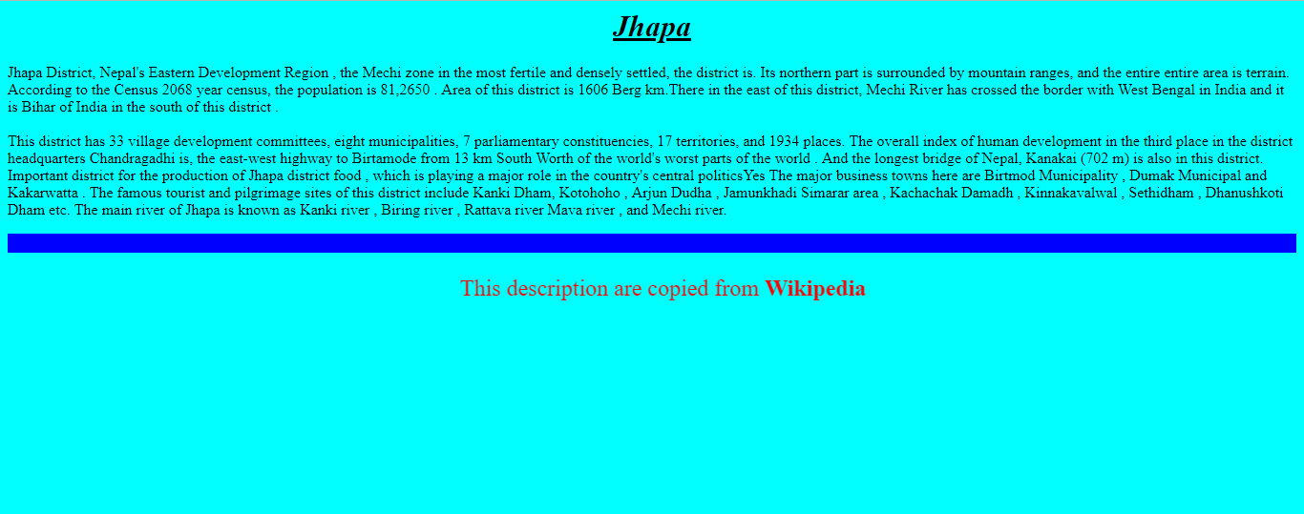

* **Gokyo Lake**

**Source Code:**

<!DOCTYPE html>

<html>

<head>

<title>Project 2</title>

</head>

<body bgcolor="light blue">

<center><h1><font color=white face=Algerian><u>Gokyo Lake</font></u></h1>

<img src="D:/gokyolakes2.jpg" height=335 width=925 title=Gokyo Lakes></center>

<p>Gokyo Lakes are oligotrophic lakes in Nepal's Sagarmatha National Park, located at an altitude of 4,700–5,000 m (15,400–16,400 ft) above sea level. These lakes are the world's highest freshwater lake system comprising six main lakes, of which Thonak Lake is the largest. In September 2007, Gokyo and associated wetlands of 7,770 ha (30.0 sq mi) have been designated a Ramsar site.Gokyo lakes are located in Khumjung Village Development Committee of Solukhumbu District in Sagarmatha Zone in north-eastern Nepal. Gokyo Cho, also called Dudh Pokhari, is the main lake with an area of 42.9 ha (106 acres), and the village of Gokyo lies on its eastern shore. Thonak Cho is the largest lake with an area of 65.07 ha (160.8 acres). Gyazumpa Cho is 29 ha (72 acres) in size, followed by Tanjung Cho with an area of 16.95 ha (41.9 acres), and Ngojumba Cho with an area of 14.39 ha (35.6 acres). As sources of permanent fresh water they have high hydrological value. They feed on waters from various sources, such as seepage from the Ngozumpa glacier, a stream coming from the Renjo La pass from north-west and another stream originating from the Ngozumpa glacier in the east. These are glacier-fed freshwater wetlands and discharge water to the Dudh Kosi headway via the Taujon Lake and the Longabanga Lake. These lakes are deeper than previously assumed by the researchers. Fourth Lake (Thonak Cho) is the deepest lake (62.4m) followed by the Gokyo Lake which is 43 m.[4] A direct connection between the Gokyo Lake and the upper Thonak Cho and the Ngozumpa Cho has not been observed, but these lakes may be connected via underground seepage water. The Gokyo lake system is naturally vulnerable, as it is lying in an ecologically fragile and unstable zone. The outburst of Ngozumpa glacier is always a threat to the existence of the lakes.

The Gokyo lake system of 19 lakes is spread over an area of 196.2 ha (485 acres) lying between 4,600 and 5,100 m (15,100 and 16,700 ft). The wetland lies on the head of the Dudh Kosi, which descends from Cho Oyu.</P>

</body>

</html>

**Output:**

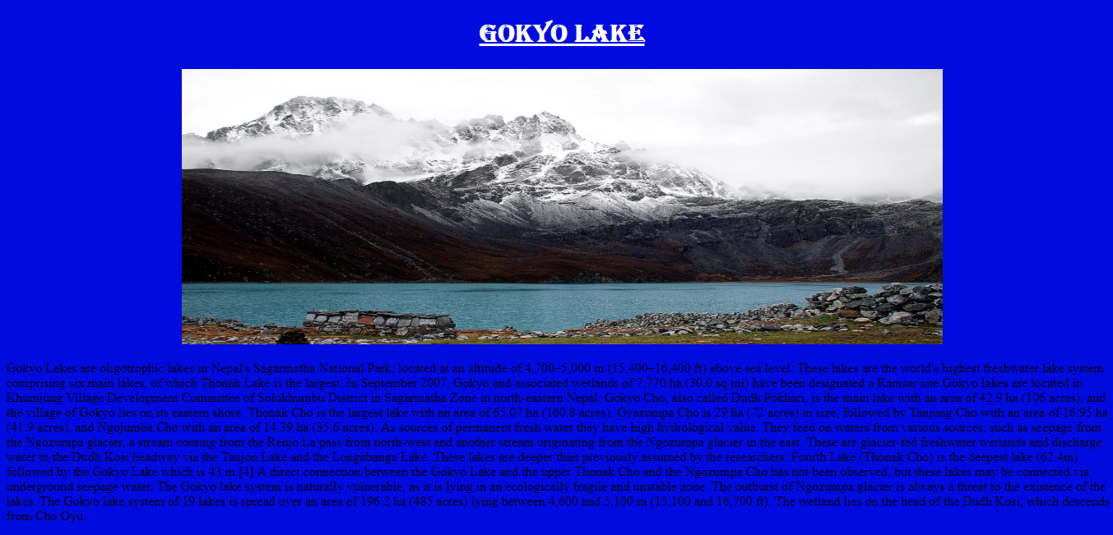

* **Photos Collection**

**Source Code:**

<html>

<head>

<title>First Project</title>

<style>

h1{text-align:center;background-color:red;color:White;padding:20px;height:100px;}

.container tr,td img:hover{border:1px solid red;}

.container tr,td img{height:800;width:1000;margin:5px;}

.detail:hover{border:1px solid red}

.detail{font-size:45px;text-align:center;border-style:inset;border-color:blue;text-decoration:none;display:inline block;}

</style>

</head>

<body>

<h1><b>Beautiful Places Of Nepal</b></h1>

<div class="container">

<table>

<tr>

<td><a href="gokyolakes1.jpg"><img src="go.jpg"><div class="detail">Gokyo Lake,</div></a></td>

<td><a href="janakimandir.jpg"><img src="janakimandir.jpg"><div class="detail">Janaki Mandir, Janakpur</div></a></td>

<td><a href="mteverest.jpg"><img src="mteverest.jpg"><div class="detail">Mt. Everest, Solukhumbu</div></a></td>

<td><a href="gosaikunda.jpg"><img src="gosaikunda.jpg"><div class="detail">Gosaikunda</div></a></td>

</tr>

<tr>

<td><a href="mustang.jpg"><img src="mustang.jpg"><div class="detail">Mustang</div></a></td>

<td><a href="haleshimahadev.jpg"><img src="haleshimahadev.jpg"><div class="detail">Haleshi Mahadev, </div></a></td>

<td><a href="rara lake.jpg"><img src="rara lake.jpg"><div class="detail">Rara Lake</div></a></td>

<td><a href="illam.jpg"><img src="illam.jpg"><div class="detail">Kanyam, Illam</div></a></td>

</tr>

</table>

</div>

</div>

</body>

</html>

**Output:**

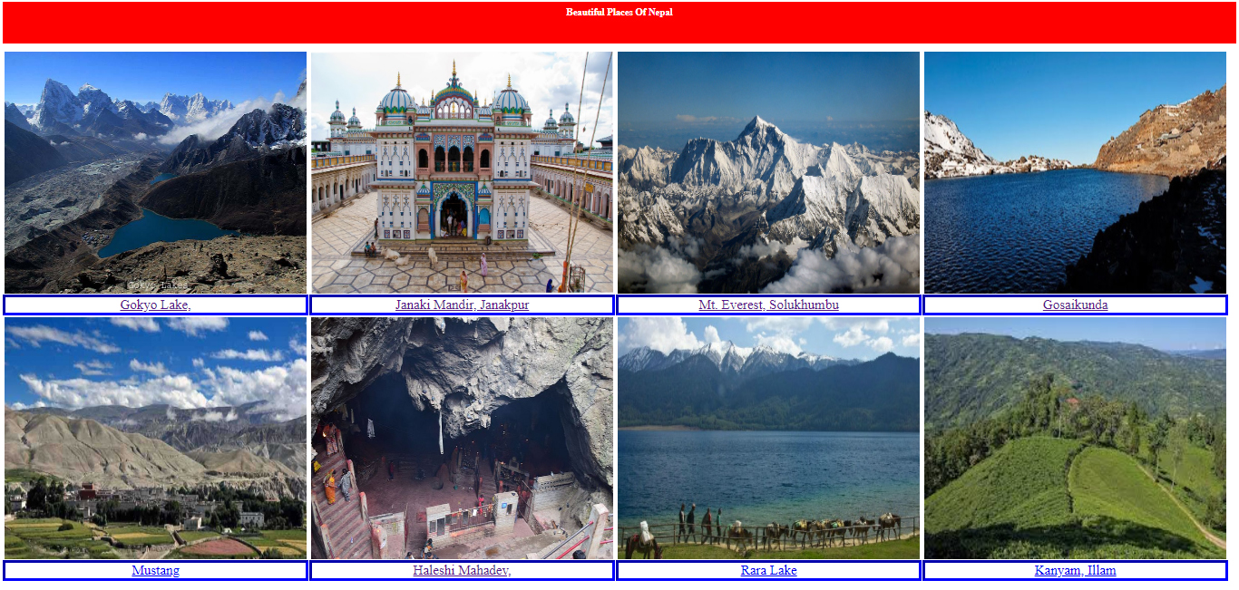

1. **Classification Of Computer**

* **Photos Collection**

**Source Code:**

<!DOCTYPE HTML>

<html>

<head>

<title>My First Website</title>

<link rel ="stylesheet" type="text/css" href="style.css"

</head>

<body>

<header>

<h1><u>Classification of Computers </u></h1>

<div id="mainbody">

<b><u>Introduction</u></b>

</div>

<p align=left> Computer is a collection of hardware and software components that helps us to complete many different task at enormous speed.

It is one of the most powerful and useful innovation in human history.These days, computer are available in many sizes and types. Computer are classified on the basis of working principle, on the basis of size, on the basis of brand and on the basis of model.

</p>

</header>

<nav>

<a href="index.html"> 1.On the basis of Working Principle</a>

<a href="size.html"> 2.On the basis of Size</a>

<a href="brand.html"> 3.On the basis Brand</a>

<a href="Model.html"> 4.On the basis of Model</a>

</nav>

<section>

<div class="rows">

<div class="column side">

<h2>Analog computer</h2>

<p>The computer which is based on continuous data is known as analog computer. It measures only physical or natural quantities such as water flow, current and voltage etc. It is used for specific purpose. The accuracy of analog computer is poor. These computers are suited for physics and engineering. Cost is low as compared to digital computer. Examples of analog devices are thermometer, clock, Plesley etc.

</p>

</div>

<div class="column middle">

<h2>Digital Computer</h2>

<p>The computer which is based on continuous data is known as analog computer. It measures only physical or natural quantities such as water flow, current and voltage etc. It is used for specific purpose. The accuracy of analog computer is poor. These computers are suited for physics and engineering. Cost is low as compared to digital computer. Examples of analog devices are thermometer, clock, Plesley etc</p>

</div>

<div class="column side">

<h2>Hybrid Computer</h2>

<p>A hybrid computer is a combination of computers which is capable of processing in both digital and analog signals. This computer's system set up with cost effective method of performing complex simulations. It accept a continuously varying input, which is then converted into a set of discrete values for digital processing.For example; ECG (Electronic Cardio Graph) monitor of a patient in hospital.</p>

</div>

</section>

<footer> Copyright &copy from Computer Science-I </footer>

</body>

</html>

**Output:**

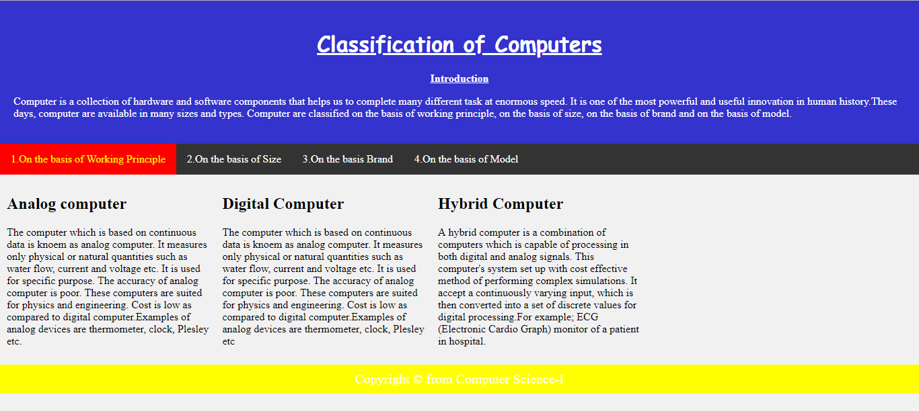

* **On The Basis Of Size**

**Source Code:**

<!DOCTYPE HTML>

<html>

<head>

<title>My First Website</title>

<link rel ="stylesheet" type="text/css" href="style.css"

</head>

<body>

<header>

<h1><u>Classification of Computers </u></h1>

<div id="mainbody">

<b><u>Introduction</u></b>

</div>

<p align=left> Computer is a collection of hardware and software components that helps us to complete many different task at enormous speed.

It is one of the most powerful and useful innovation in human history.These days, computer are available in many sizes and types. Computer are classified on the basis of working principle, on the basis of size, on the basis of brand and on the basis of model.

</p>

</header>

<nav>

<a href="index.html"> 1.On the basis of Working Principle</a>

<a href="size.html"> 2.On the basis of Size</a>

<a href="brand.html"> 3.On the basis Brand</a>

<a href="Model.html"> 4.On the basis of Model</a>

</nav>

<section>

<div class="rows">

<div class="column side">

<h2>Super Comuter</h2>

<p>A supercomputer is the fastest type of computer which perform at a rate of speed which is far above that of other computer which harness immense processing speed so that they are incredibly fast, sophisticated and powerful.This computer have multiple processor and a variety of other technological tricks to ensure that they run smoothly.Its word length is more than 128 bits.<br>

Example:CRAY-3, CYBER 205, PARAM etc </p>

</div>

<div class="column middle">

<h2>Mainframe Computer</h2>

<p>Mainframe is large, powerful, expensive computers used mainly by large company for bulk data processing,commercial data processing and other large scale operations such as bank transaction processing.It is general purpose computing system.It is very large in size with 1000sq.ft approximately and supports large number of terminals, more than 100 terminals. It word length is more than 64 bits.<br>Examples:IBM's ES000, VAX 8000, CDC 6600 etc.</p>

</div>

<div class="column middle">

<h2>Mini computer</h2>

<img src:"mini.jpg">

<p>Mini computer are computer that are somewhere in between a microcomputer and a mainframe computer.This computer are smaller, less expensive and less powerful than a mainframe computer but more than a personal computer.They can support about 50 terminal and require 100 sq. ft area approximately.They are used for scientific and engineering computations, file handling and database management, business transaction processing etc.<br>Examples:PDP 11, VAX 7500 etc.</p>

</div>

<div class="column side">

<h2>Micro computer</h2>

<p>A microcomputer is a small sized personal computer that designed for an individual having microprocessor inside it. It contains a CPU on a microchip, a memory system, a bus system and I/O ports, typically housed in a motherboard.Microcomputer are designed to be used by individuals, whether in the form of PC's, workstations or notebook computers.This computer are useful for entertainment, business purposes etc.<br>Example: IBM's PC, Apple/Machintosh, Dell etc. </p>

</div>

</div>

</section>

<footer> Copyright &copy from Computer Science-I </footer>

</body>

</html>

**Output:**

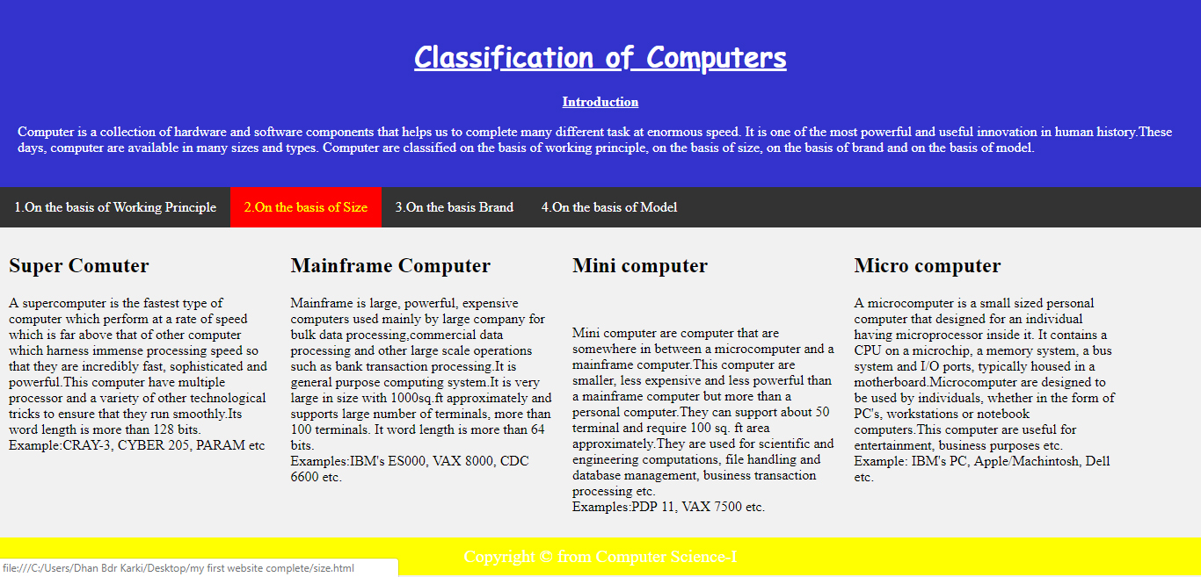

* **On The Basis Of Brand**

**Source Code:**

<!DOCTYPE HTML>

<html>

<head>

<title>My First Website</title>

<link rel ="stylesheet" type="text/css" href="style.css"

</head>

<body>

<header>

<h1><u>Classification of Computers </u></h1>

<div id="mainbody">

<b><u>Introduction</u></b>

</div>

<p align=left> Computer is a collection of hardware and software components that helps us to complete many different task at enormous speed.

It is one of the most powerful and useful innovation in human history.These days, computer are available in many sizes and types. Computer are classified on the basis of working principle, on the basis of size, on the basis of brand and on the basis of model.

</p>

</header>

<nav>

<a href="index.html"> 1.On the basis of Working Principle</a>

<a href="size.html"> 2.On the basis of Size</a>

<a href="Brand.html"> 3.On the basis Brand</a>

<a href="Model.html"> 4.On the basis of Model</a>

</nav>

<section>

<div class="rows">

<div class="column side">

<h2>IBM Computer</h2>

<p>IBM computer stands for "International Business Machine Computer" which is made by IBM Company.IBM Company was established by Dr. Herman Hollerith in 1923 A.D. and it is the largest computer manufacturing company in the world till today. The IBM computer are more reliable, durable,and have higher processing capability. It is also called IBM branded computer as its whole part are developed by IBM itself.

IBM computer are very famous for data processing and store.</p>

</div>

<div class="column middle">

<h2>IBM Compatible</h2>

<p>The word compatible means 'able to exist together and work successfully.So. in IBM compatible, the components of the computer are developed by different companies and finally, they are assemble and a computer is made.So it is also called an assembled PC.They are very cheaper than branded pc or IBM PC. Some of the most popular IBM compatible PCs are Dell, Lenovo, Toshiba etc.</p>

</div>

<div class="column side">

<h2>Apple/Machintosh</h2>

<p>Apple Corporation is the largest computer manufacturers which is in USA. It has made several PC eith good qualities and user friendly and the internal architecture of Apple computer are totally diferent than that of IBM PC. The software made for Apple Computer can't be used in IBM PC or vice versa. </p>

</div>

</div>

</section>

<footer> Copyright &copy from Computer Science-I </footer>

</body>

</html>

**Output:**

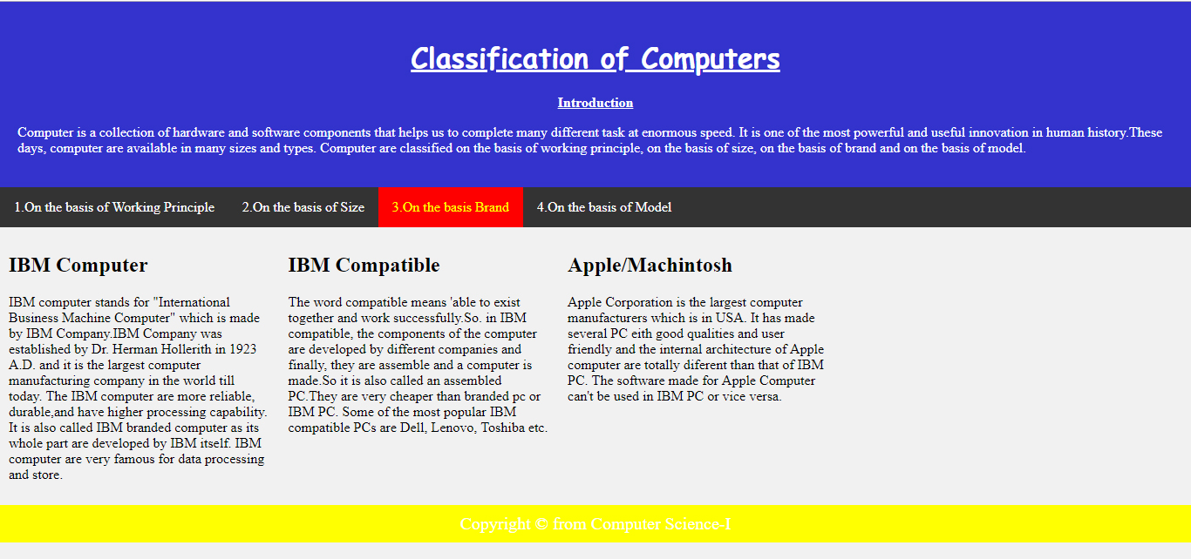

* **On The Basis Of Model**

**Source Code:**

<!DOCTYPE HTML>

<html>

<head>

<title>My First Website</title>

<link rel ="stylesheet" type="text/css" href="style.css"

</head>

<body>

<header style:"background-color:#3333cc;">

<h1><u>Classification of Computers </u></h1>

<div id="mainbody">

<b><u>Introduction</u></b>

</div>

<p align=left> Computer is a collection of hardware and software components that helps us to complete many different task at enormous speed.

It is one of the most powerful and useful innovation in human history.These days, computer are available in many sizes and types. Computer are classified on the basis of working principle, on the basis of size, on the basis of brand and on the basis of model.

</p>

</header>

<nav>

<a href="index.html"> 1.On the basis of Working Principle</a>

<a href="size.html"> 2.On the basis of Size</a>

<a href="brand.html"> 3.On the basis Brand</a>

<a href="Model.html"> 4.On the basis of Model</a>

</nav>

<section>

<div class="rows">

<div class="column side">

<h2>XT Computer</h2>

<p>XT stands for "eXtra Technology" and these computers are the old technology computer. XT uses CUI (Character User Interface) or text based software. They don't have large storage capacity and faster processing speed, so complex calculation and large data processing can't be done. Even the I/O devices used in XT computers are not very flexible and faster. Having processor Intel 8085/8086/ 8088 lies under the XT technology. </p>

</div>

<div class="column middle">

<h2>AT Computer</h2>

<p>AT stands for "Advanced Technology" and these computers are the new technology computers. AT uses advanced GUI based software as well as CUI based software. Their I/O devices are interactive, flexible and faster. Because of their high speed processor and large storage capacity, complex calculation and large data processing can be done easily. Having Processor Pentium 80286/ 386/ 488 lies under the AT technology.</p>

</div>

<div class="column middle">

<h2>PS/2 Computer</h2>

<p>Ps stands for 'Personal System' and actually these are not totally different models of computers but actually are refinement of faster AT computers. PS/2 model was developed after 1990 and mainly used in laptop computers. So these computers can run even on battery. They have faster and flexible I/O devices and uses GUI based software.</p>

</div>

</div>

</section>

<footer> Copyright &copy from Computer Science-I </footer>

</body>

</html>

**Output:**

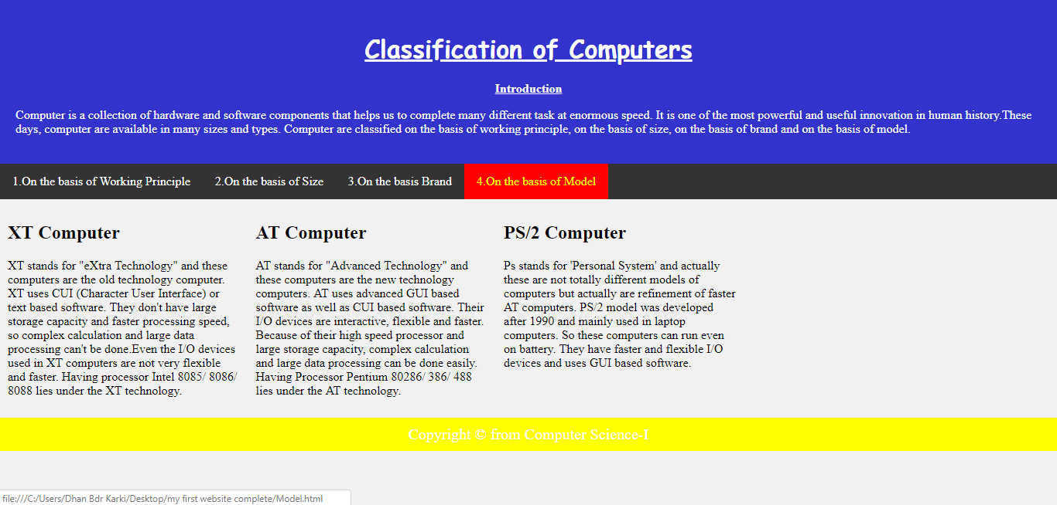

* External CSS style sheet for Classification of Computer

Code:

body{margin:0;background-color:#f1f1f1;}

header{background-color:#3333cc;color:white;padding:20px;text-align:center;}

h1{font-family:"Comic Sans MS"; }

div id{text-align:left;font-size:20px;}

nav{overflow:hidden;background-color:#333;}

nav a{float:left;color:#fff;padding:14px 16px;text-decoration:none;}

a:hover{background-color:red;color:yellow;}

.column{float:left;padding:10px;}

.column.side{width:22%;}

.column.middle{width:22%}

footer{background-color:yellow;text-align:center;clear:both;color:white;font-size:20px;padding:10px;}

**B.Generation Of Computer**

* **Characteristics of Generation of Computer**

**Source Code:**

<!DOCTYPE html>

<html>

<head>

<title>Generation of computer in table</title>

</head>

<body bgcolor="red">

<center><h1><u width=100>Characteristics of Generation of computer in Table</u></h1></center>

<table border=2 width=1000 bgcolor="#FFFF00" align="center" height="500">

<tr>

<th colspan=6>Generation of Computer</th>

</tr>

<tr>

<th> </th>

<th> First Generation</th>

<th> Second Generation</th>

<th>Third Generation</th>

<th>Fourth Generation</th>

<th>Fifth Generation</th>

</tr>

<tr><td><b> Time period</b></td>

<td> 1940-1956</td>

<td>1956-1963</td>

<td> 1964-Early's 1970</td>

<td>Early's 1970-Till date</td>

<td>Present and beyond</td>

</tr>

<tr><td><b>Technology</b></td>

<td>Vacuum tubes</td>

<td>Transistor </td>

<td> Integrated Circuits</td>

<td>Microprocessor</td>

<td> Bio-chips</td>

</tr>

<tr><td><b> Processing Speed</b></td>

<td> Millisecond</td>

<td>Microsecond</td>

<td> Nanosecond</td>

<td> Picosecond</td>

<td> More Than Femtosecond</td>

</tr>

<tr><td><b>Memory</b></td>

<td>Vacuum Tubes</td>

<td>Magnetic Cores</td>

<td> Semiconductors</td>

<td>Semiconductors</td>

<td><Super-conductor/td>

</tr>

<tr><td><b>Storage</b></td>

<td>Magnetic tapes/drums</td>

<td>Magnetic tapes/disks</td>

<td> Magnetic Disks</td>

<td>Magnetic disks/ optical disks</td>

<td>Magnetic disks/ optical disks</td>

</tr>

<tr><td><b>I/O device</b></td>

<td>Punch Cards</td>

<td>Punch Cards</td>

<td> Keyboards/Monitor</td>

<td>Keyboards/Monitor/others</td>

<td>Advancement in I/O</td>

</tr>

<tr><td><b>size, cost, power consumption, heat generation</b></td>

<td>Very High</td>

<td>High</td>

<td>High </td>

<td>Very High</td>

<td>Very low</td>

</tr>

<tr><td><b>Reliability and Accuracy</b></td>

<td>Not Fully</td>

<td>More than 1G</td>

<td>Fully than previous </td>

<td>Fully than previous</td>

<td>-</td>

</tr>

<tr><td><b>Programming Languages</b></td>

<td>Machine</td>

<td>Assembly and High Level</td>

<td> High Level(Third Generation)</td>

<td>High Level(Fourth Generation) </td>

<td>Natural Language</td>

</tr>

<tr><td><b>Examples</b></td>

<td>IBM 700 Series, ENIAC, EDVAC etc</td>

<td>IBM 1620, IBM 7090, PDP1 etc</td>

<td>IBM 370 Series, CDC 7600, PDP 11,etc </td>

<td>IBM PC,Pentium PC, Apple etc</td>

<td></td>

</tr>

</body>

</html>

**Output:**

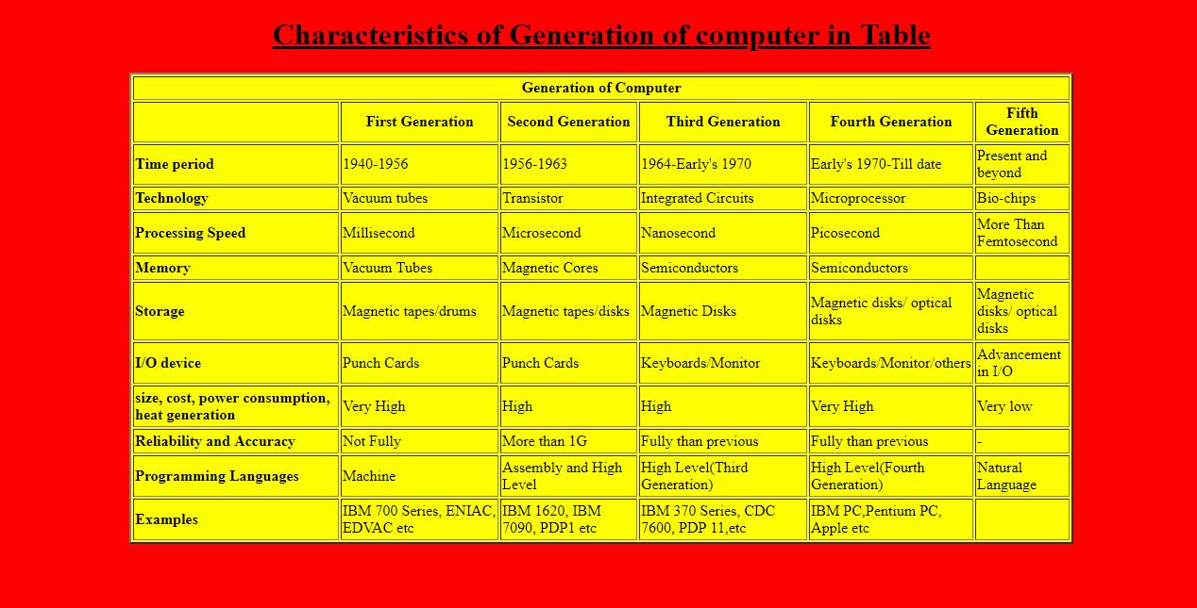

**C. Miscellaneous Subject**

* Characteristics of Generation of Computer

**Source Code:**

<html>

<head>

<title>Form Complete</title>

<style>

body{

background-color:green;

margin:50;

}

.container{

border:1px solid black;

background-color:#33cccc;

color:red;

padding:10px;

margin:auto;

max-width:450px;

}

input[type=submit]:hover{

background:#3366cc;

}

input[type=reset]:hover{

background:#00cc00;

}

</style>

</head>

<body>

<font color=red>

<form action="https://www.gmail.com" action="post">

<div class="container">

<table align=center>

<center><h2><b><u>Your DBK Account<b></h2></u></center>

<tr>

<td>

Name: <input type="text" name="" placeholder="Name">

</td></tr>

<tr><td>Gender:

</td></tr>

<tr><td>

<input type="radio" name="gender" value="male" checked> Male<br>

<input type="radio" name="gender" value="female"> Female<br>

<input type="radio" name="gender" value="other"> Other

</tr></td>

<tr><td>Country: <select size=1>

<option>Nepal</option>

<option>India</option>

<option>America</option>

<option>Denmark</option>

<option>France</option>

<option>Germany</option>

</select>

</td></tr>

<tr><td>Address: <input type="text" name="Country" placeholder="Haldibari-3,jhapa" value="" ></td></tr>

<tr><td>Email: <input type="text" placeholder="john@gmail.com" name="" value=""></td></tr>

<tr><td>Upload photo:<br>

<input type="file"></td></tr>

<tr><td>Hobbies:<input type="checkbox">Movie

<input type="checkbox">Music

<input type="checkbox">Game</td></tr>

<tr><td>Experiences:<br><textarea rows=3 cols=50 placeholder="write about your qualification and experience"></textarea></td></tr>

<tr><td><input type="submit" value="Login">

<input type="reset" value="clear"></td></tr>

</table>

</font>

</div>

</form>

</body>

</html>

**Output:**

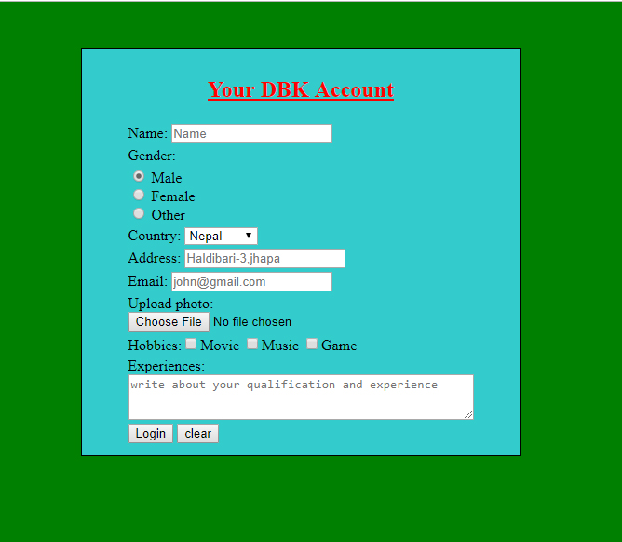

**Conclusion**

I got a wonderful and learning experience for me while working on this project. This project took me through the various phases of project development and gave me the real insight into the world of web page designing. The joy of working and the thrill involve while tackling the various problems and challenges gave me a feel of good web developers. I started the work from the first day I got copy of my assignment and completed about 25% on the vary day. The research that I and my friend did encourage me to get more projects and take a challenge of completing within allocated time. I got opportunity to revise the lessons that we have gone through. Teacher’s coordination and perfect touch with our group made me an opportunity to interact with teacher. I really enjoyed doing this project as a formal job. Now, I’m satisfied with my project work.

**Bibliography**

A. Computer Science, Grade XI

B. Wikipedia [en.wikipedia.org]

C. Google [www.google.com]